**1.What is Cloud computing?**

cloud computing is the on-demand delivery IT resource over internet with pay on you go pricing.

Instead of buying, owning and maintaining physical data center and servers.

we can access technology services such as compute power, storage, network etc...

on needed basis which is provided by cloud vendors like AWS, AZURE, GCP, IBM CLOUD

**2.Difference Public, private and hybrid**

**3**. **Vocabulary and Terminology**

• **Virtualization:** The creation of a virtual version of something, such as hardware, storage devices, or network resources. It allows multiple virtual environments to run on a single physical system, providing efficient utilization of resources.

• **Virtual Machine (VM):** A software-based emulation of a physical computer, which runs an operating system and applications just like a physical machine. VMs provide isolated environments for different tasks, even on the same physical hardware.

• **API (Application Programming Interface):** A set of rules and protocols for building and interacting with software applications. APIs allow different systems to communicate and interact with each other by exposing specific functionality.

• **Regions:** In cloud computing, a region is a geographic area where cloud providers have data centers. Regions allow users to deploy their services closer to their customers to reduce latency and improve performance.

• **Availability Zone (AZ):** A physical location within a cloud region that contains one or more data centers. Availability Zones provide redundancy and isolation from failures, helping to ensure higher availability for cloud applications.

• **Scalability:** The ability of a system, network, or process to handle a growing amount of work or to expand in response to increased demand. It can refer to both scaling up (increasing the capacity of a single resource) and scaling out (adding more resources to a system).

• **High Availability:** A design approach to ensure that a system or service remains operational for as long as possible, minimizing downtime and avoiding service interruptions. It typically involves redundant systems, fault tolerance, and load balancing.

• **Disaster Recovery**: A set of strategies and procedures used to recover from catastrophic events, such as system failures, data loss, or natural disasters, to restore critical systems and minimize downtime.

• **Load Balancing**: The process of distributing incoming network traffic across multiple servers to ensure no single server becomes overwhelmed. Load balancing helps to improve the responsiveness and availability of applications by sharing the workload.

**4. Different segments SaaS, PaaS, and IaaS**

SaaS, PaaS, and IaaS are different segments of cloud computing services, each offering different levels of abstraction and management. Here's a brief overview of each:

**1. SaaS (Software as a Service):**

* **Definition:** SaaS provides software applications over the internet, eliminating the need for users to install, maintain, or manage the underlying hardware and infrastructure.

**Examples:** Google Workspace (formerly G Suite), Microsoft 365, Salesforce, Zoom.

1. **Amazon Chime:** A communication service for online meetings, video conferencing, and business calling.
2. **Amazon WorkDocs:** A secure enterprise document storage and sharing service.
3. **Amazon QuickSight:** A business analytics service for creating and sharing data visualizations and insights.

* **Usage:** End-users access applications directly via the web or an API. The provider handles all aspects of maintenance, updates, and security.

**2. PaaS (Platform as a Service):**

* **Definition:** PaaS offers a platform that allows developers to build, run, and manage applications without worrying about the underlying infrastructure. It includes operating systems, databases, development frameworks, and more.

**Examples:**

1. **AWS Elastic Beanstalk:** An easy-to-use service for deploying and managing applications. It automatically handles the details of capacity provisioning, load balancing, scaling, and application health monitoring.
2. **AWS Lambda:** A serverless computing service that allows you to run code in response to events without provisioning or managing servers.
3. **Amazon RDS (Relational Database Service):** A managed database service that supports several database engines like MySQL, PostgreSQL, Oracle, and SQL Server.

* **Usage:** Developers use PaaS to focus on coding and application logic. The provider manages servers, storage, networking, and other resources.

**3. IaaS (Infrastructure as a Service):**

* **Definition:** IaaS provides virtualized computing resources over the internet, such as virtual machines, storage, and networking. It offers the most flexibility but requires users to manage more aspects of the system.
* **Examples:** Amazon Web Services (AWS EC2), Microsoft Azure Virtual Machines, Google Compute Engine.
* **Usage:** Users have control over operating systems, storage, and deployed applications, but the provider manages the underlying hardware.

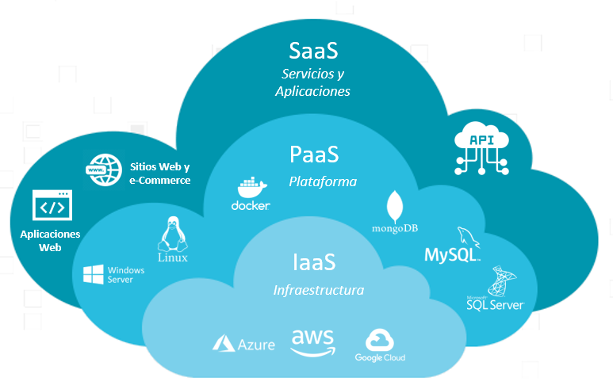

**Comparison:**

* **SaaS:** Ready-to-use applications.
* **PaaS:** Platform for building applications.
* **IaaS:** Infrastructure for hosting any applications.

These segments provide different levels of control and responsibility, catering to various user needs from simple software usage to full-scale infrastructure management.

**5. Launch EC2 Instance**